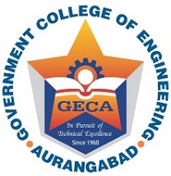 | GOVERNMENT COLLEGE OF ENGINEERING AURANGABAD  “In Pursuit of Global Competitiveness”  (An Autonomous Institute of Government of Maharashtra)

FORM For COURSE RE-REGISTRATION /CLASS TEST IMPROVEMENT
Semester: ODD Academic Year: 2021-2022

(Tick the appropriate one) – IMPROVEMENT / RE-REGISTRATAION

IMPORTANT INSTRUCTIONS FOR STUDENTS :
1. Tick on the appropriate option for which you want to apply i.e. IMPROVEMENT or RE-REGISTRATION. If a student fails to select the option then the form will be rejected.
2. Apply within the last date and time no application will be accepted after the last date and time.
3. Apply in this format only. No handwritten application or any other application will be accepted.
4. If a student wish to apply for RE-REGISTRATION of some subjects and IMPROVEMENT for some subjects then student have to apply separately i.e. one form for Re-Registrations & other for Class test Improvement.
5. Form must be sent on the email address academics6@geca.ac.in

Name (in Capital letters) | :
Enrolment No. | :
Department | :

Sr. No. | Course Code | Course Name | Course Credit | Name of the Department offering the Course

Signature of the Student Signature of the Faculty Advisor Head of the Department

Date: / /

